Sophie Scholl beheaded

22nd February 1943: Youngest member of the tiny 'White Rose Resistance Movement' is one of six executed for distributing anti Nazi leaflets
FEB 22

SAVE |  | ▷ LISTEN

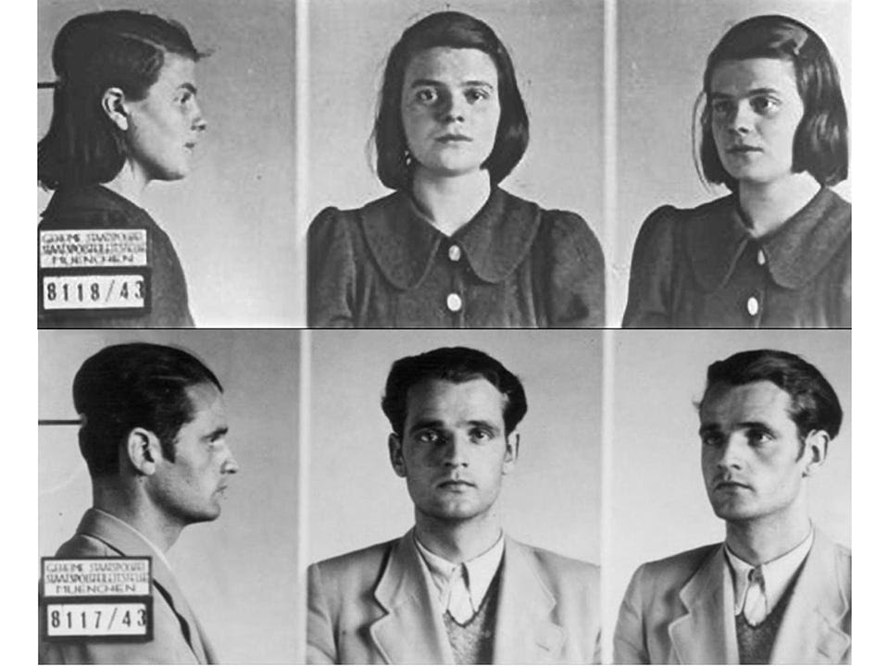
Mug shots of Sophie and Hans Scholl after their arrest by the Gestapo on 18th February 1943.
In their school days Hans and Sophie Scholl had been fascinated by the Nazi movement. Hans had had a high rank in the Hitler Youth organisation and Sophie a similar position in the League of German Girls. Yet as they grew older and witnessed the progress of the war they became highly critical of the Nazi regime, realising that it ran counter to their most deeply held values.
As a medical student Hans found himself posted to Russia on military service and witnessed the conduct of the German armed forces and the actions against the Jews. On returning to Munich University in 1942 he and a group of fellow students formed the 'White Rose Resistance Movement'. When Sophie entered the University in 1942 she also joined the group.
"Somebody, after all, had to make a start. What we wrote and said is also believed by many others. They just do not dare express themselves as we did."
Between June 1942 and February 1943 the group distributed six different leaflets denouncing Hitler and the Nazi regime. Readers were urged to"Support the resistance movement!" in the struggle for "Freedom of speech, freedom of religion, and protection of the individual citizen from the arbitrary action of criminal dictator-states".
Thousands of leaflets were produced using a hand-cranked printing machine and they reached most of the major cities in Germany.
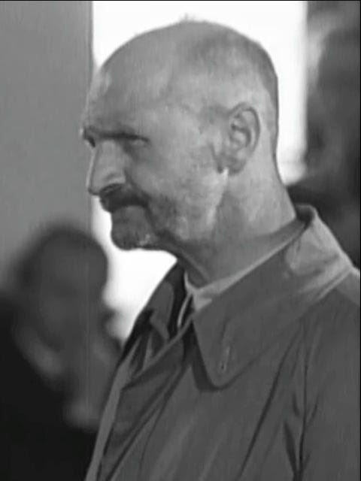
Jakob Schmid, the university caretaker who caught Sophie and Hans Scholl, was a member of the Nazi Party. He received a reward of 3,000 Reichsmarks and was promoted. He was considered a ‘major offender’ in the post-war de-Nazification process and served 5 years hard labour.
On the 18th February Hans and Sophie were distributing a suitcase full of leaflets in the University. They were intended to be found by students attending lectures the following day. But they were caught in the act by the University caretaker and eventually handed over to the Gestapo.
Despite their efforts not to betray the other members of their group, the Gestapo eventually arrested all six of them.
The Sixth Flyer of the White Rose Resistance Movement, from February 18, 1943¹:
Fellow students! Fellow students!
Our people, shaken, face the loss of the men of Stalingrad. Three hundred and thirty thousand German men have been senselessly and irresponsibly driven to death and destruction by the inspired strategy of our World War I Private First Class. Führer, we thank you.
…
We grew up in a state in which all free expression of opinion was unscrupulously suppressed. The Hitler Youth, the SS, have tried to drug us, to revolutionize us, to regiment us in the most promising young years of our lives."Philosophical training" is the name given to the despicable method by which our budding intellectual development was smothered in a fog of empty phrases. An unimaginably diabolical and narrow-minded selection process trains its chosen future party bigwigs in the "Castles of the Knightly Order" to become brazen, godless, unscrupulous exploiters and assassins –– blind, moronic hangers-on of the Führer.
…
For us there is but one slogan: fight against the Party! Get out of Party organizations, which are used to keep our mouths sealed and hold us in political bondage! Get out of the lecture rooms of the SS corporals and sergeants and the party bootlickers! We want genuine learning and real freedom of opinion. No threat can terrorize us, not even the shutting down of institutions of higher learning. This is the struggle of each and every one of us for our future, our freedom, and our honor under a regime conscious of its moral responsibility.
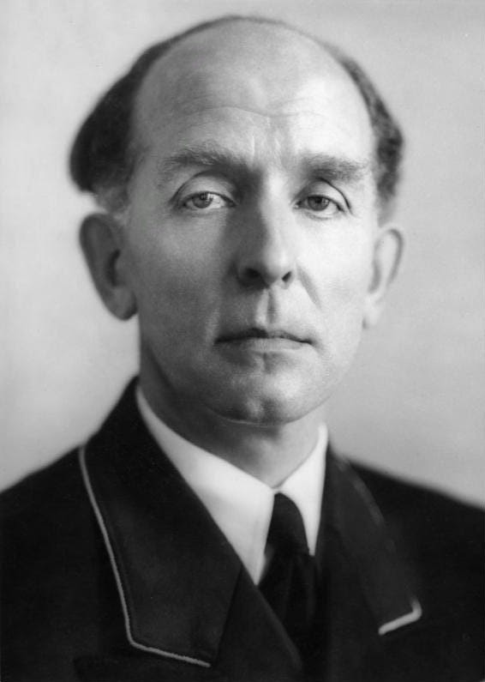
President of the People's Court from 1942 to 1945, Roland Freisler (1893-1954) was flown into Munich for the sole purpose of presiding over the “trial”. He was killed by a USAAF bomb during a raid on Berlin in February 1945.
When the came up before the Nazi 'People's Court' chaired by the notorious Roland Freisler on the 22nd February there was not much hope for them. He acted as prosecutor, judge and jury in his own conception of 'Nazi justice' and had a record of convicting over 90% of the people appearing in his court and sentencing them to death.
Hans and Sophie were treated no differently. They remained defiant to the end, Sophie then aged 22, is recorded as saying
"Somebody, after all, had to make a start. What we wrote and said is also believed by many others. They just do not dare express themselves as we did."
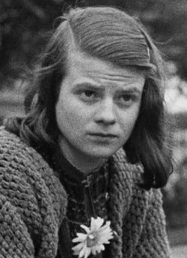
Sophie Scholl in 1942, she was 21 when executed.
Within hours of their conviction they were beheaded by guillotine at Munich's Stadelheim Prison. Prison officials emphasized the courage with which Sophie walked to her execution. Her last words were "Die Sonne scheint noch"—"The sun still shines."
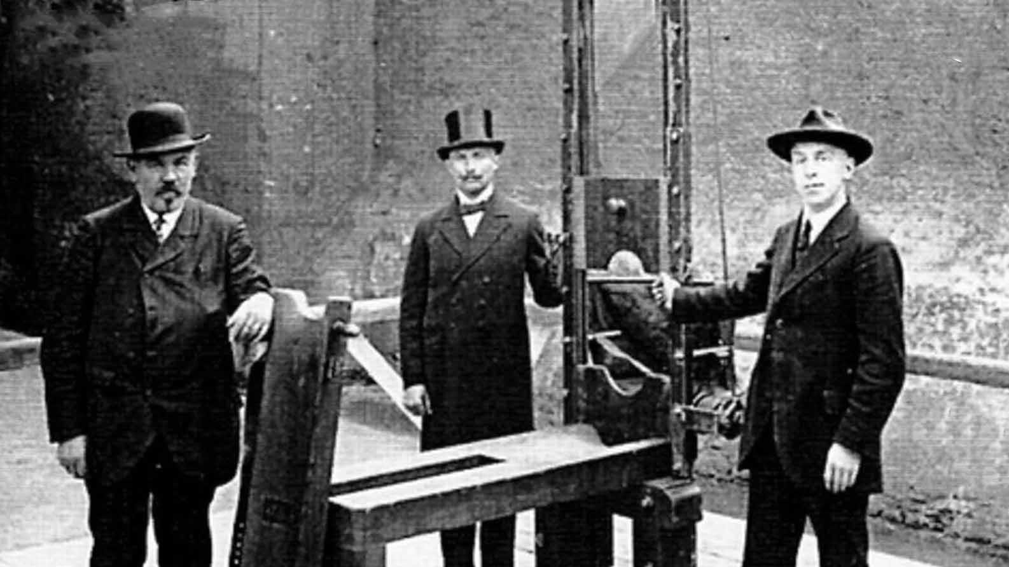
The guillotine at Stadelheim Prison, the staff wore funeral directors style uniform.
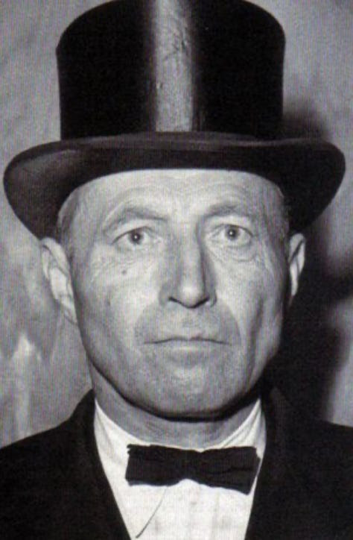
Johann Reichhart ‘the Head Hunter’, the principal executioner, took over the job from his uncle. He carried out 2,873 executions by guillotine for the Nazis in the Second World War. After the war, he was employed by the US authorities and executed a further 156 low-rank Nazi war criminals, by hanging.
1
The leaflet was smuggled out of Germany and was reprinted as the ‘The Manifesto of the Students of Munich’. Millions of copies were dropped by the RAF across Germany; the full text of the leaflet (translated) is at forensicgenealogy.info.

